CPE301 – SPRING 2019

Design Assignment 2A

Student Name: Clayton Higbee

Student #:5001189864

Student Email: higbee@unlv.nevada.edu

Primary Github address: <https://github.com/claytonjhigbee/CODSWORTH_MAIN>

Directory: <https://github.com/claytonjhigbee/CODSWORTH_MAIN/tree/master/DA/DA2A>

Please note: Each task folder (DA2AT1 and DA2AT2) have both the Assembly and C Codes inside the same project for convenience. Merely open the overall project and both codes will be available in the Solution Explorer of Atmel Studio.

1. **COMPONENTS LIST AND CONNECTION BLOCK DIAGRAM w/ PINS**

Components used:

Atmega328P Xplained Mini Board

Female to Male Wires (For logic analyzer Connections)

Logic Analyzer

Multi-Function Development Board Shield

Block diagram with pins used in the Atmega328P

(Schematic only for Task 2 as Task 1 required no parts)

PortC.2 – Input for Switch

PortB.2 – Output for LED, used with Danger Shield

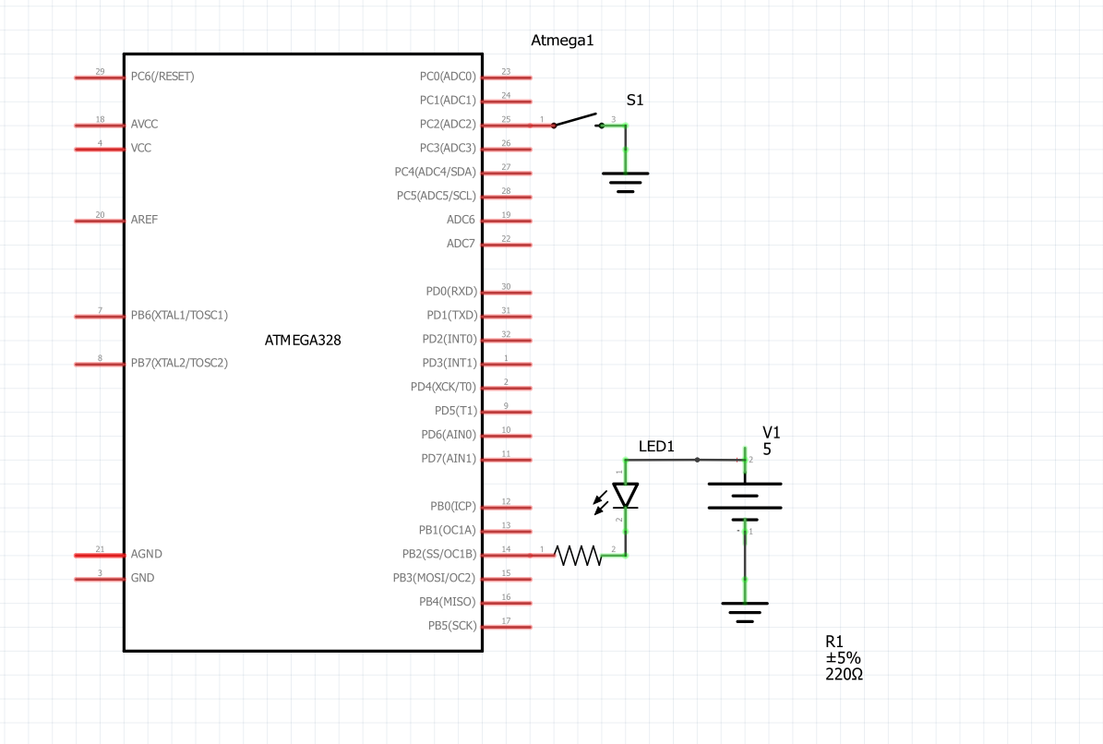

1. **INITIAL/MODIFIED/DEVELOPED CODE OF TASK 1/A**

**Assembly Code:**

;

; WaveformGenerator.asm

;

; Created: 2/26/2019 8:13:42 PM

; Author : clayt

;

.ORG 0

LDI R20, 0xFF ; Load Immediate into R20

OUT DDRB, R20 ; Set all Pins of Port B as output only

LDI R19, 4 ; Value to set clock prescalar to 256

STS TCCR1B, R19 ; Set clock prescalar

START:

LDI R20, 0x00 ; Used for resetting counter

STS TCNT1H, R20 ; Set counter high byte to zero

STS TCNT1L, R20 ; set counter low byte to zero

LDI R21, 0b00000100 ; Load immediate binary number into R21, to be used to set PORTB.2 HIGH

OUT PORTB, R21 ; Set PORTB.2 HIGH

RJMP DELAYHIGH0 ; Delay for 60% of total time

L1:

LDI R21, 0b00000000 ; Load immediate binary number into R21, to be used to set PORTB.2 LOW

LDI R29, 0 ; Load 0 into R29 to reset High byte of Clock

LDI R28, 0 ; Load 0 into R28 to reset Low byte of Clock

STS TCNT1H, R29 ; Load upper byte of Clock

STS TCNT1L, R28 ; Load lower byte of Clock

OUT PORTB, R21

RJMP DELAYLOW0 ; Delay for 40% of total time

DELAYHIGH0:

; Hold the Function HIGH for 60% of the overall time: 0s to 435ms

LDS R29, TCNT1H ; Load upper byte of Clock

LDS R28, TCNT1L ; Load lower byte of Clock

CPI R28, 0x01 ; Compare lower byte to see if time was reached

BRSH DELAYHIGH1 ; If lower byte has been reached, check upper byte

RJMP DELAYHIGH0 ; Else continue to check lower byte

DELAYHIGH1:

CPI R29, 0x6A ; Check if Upper byte has reached desired time

BRLT DELAYHIGH0 ; If not check lower byte again

RJMP L1 ; If upper byte has reached, then set PORTB.2 LOW

DELAYLOW0:

; Hold the Function HIGH for 40% of the overall time: 435ms to 725ms

LDS R29, TCNT1H ; Load upper byte of Clock

LDS R28, TCNT1L ; Load lower byte of Clock

CPI R28, 0xFF ; Compare lower byte to see if time was reached

BRSH DELAYLOW1 ; If lower byte has been reached, check upper byte

RJMP DELAYLOW0 ; Else continue to check lower byte

DELAYLOW1:

CPI R29, 0x46 ; Check if Upper byte has reached desired time

BRLT DELAYLOW0 ; If not check lower byte again

RJMP START ; If upper byte has reached, then set PORTB.2 HIGH and start over

Assembly code performed the function but was difficult to setup timer for the correct delay.

**C Code:**

/*

* WaveformGeneratorCcode.c

*

* Created: 3/1/2019 9:24:05 AM

* Author : clayt

*/

#define *F_CPU* 16000000UL

#include <avr/io.h>

#include <util/delay.h>

int main(void)

{

DDRB = 0xFF; // Configure Port B as an output

while (1)

{

PORTB |= (1<<PB2); // Set Port B High

*_delay_ms*(435); // Delay 435ms

PORTB &= ~(1<<PB2); // Set Port B Low

*_delay_ms*(290); // Delay 290ms

} // Repeat

}

C Code was really impressive, easy to setup and was really accurate in the desired delay.

1. **INITIAL/MODIFIED/DEVELOPED CODE OF TASK 2/A**

**Assembly Code:**

;

; SwitchControlledLED.asm

;

; Created: 3/1/2019 9:50:32 AM

; Author : clayt

;

.ORG 0

LDI R22, 0 ; Load immediate into R22

LDI R16, 0xFF ; Load immediate into R16

OUT DDRB, R16 ; Set DDRB as output

OUT DDRC, R22 ; Set DDRC as input

OUT PORTC, R16 ; Set Port C pull up resistors

LDI R17, 0 ; Register needed to toggle the LED

OUT PORTB, R16 ; Set Port B and related Pins HIGH to set LEDs to LOW

LDI R20, 5 ; Set Clock prescalar to 1024

STS TCCR1B, R20 ; Input Clock prescalar

CHECK:

IN R26, PINC ; Check current PinC input

COM R26 ; Take compliment of R26

ANDI R26, 0x04 ; Logical AND with immediate

CPI R26, 0x04 ; Compare with immediate

BRNE CHECK ; Check to see if PinC.2 has been pressed, if not, CHECK again

BEGIN: ; If switched pressed, begin delay

LDI R25, 0x00 ; Reset Timer

STS TCNT1H, R25 ; Reset Timer HIGH

STS TCNT1L, R25 ; Reset Timer LOW

OUT PORTB, R22 ; Set LED Port B to Low (REVERSE LOGIC)

DELAY0:

LDS R29, TCNT1H ; Loading upper byte of Timer to R29

LDS R28, TCNT1L ; Loading lower byte of Timer to R28

CPI R28, 0x4A ; Compare with Immediate

BRSH DELAY1 ; Branch if same or higher to DELAY1 label

RJMP DELAY0 ; Else contine to check on Timer Lower byte

DELAY1:

CPI R29, 0x4C ; Compare to immediate

BRSH DONE ; If timer is met, Branch to DONE label

RJMP DELAY0 ; Else check Timer low byte again

DONE:

; Reset HIGH and LOW bytes for Timer

LDI R25, 0x00

STS TCNT1H, R25

STS TCNT1L, R25

OUT PORTB, R16 ; Set LED Port B to High (REVERSE LOGIC)

RJMP CHECK ; Return to CHECK label

Similar to task 1, required a bit of work to setup correctly. It does allow the user to know exactly what is taking place in the registers.

**C Code:**

/*

* SwitchControlledLEDCCode.c

*

* Created: 3/2/2019 8:25:24 AM

* Author : clayt

*/

#define *F_CPU* 16000000UL

#include <avr/io.h>

#include <util/delay.h>

int main(void)

{

DDRB = 0xFF; // Set Port B as an output

DDRC = 0x00; // Set Port C as an input

PORTC = 0xFF; // Set Pull up resistors in Port C

while (1)

{

PORTB = 0b00111100; // Set LED Port B to Low (REVERSE LOGIC)

if(PINC == 0x7D) ; // If switch push is detected, then set LEDs

{

PORTB = 0b00000000; // Set LED Port B to High (REVERSE LOGIC)

*_delay_ms*(1250); // Delay for 1.25 seconds

}

}

}

C Code was straightforward, but the coder needs to realize that the LEDs are reverse logic. It requires a Logical High to turn off and Logical Low to turn on.

1. **DEVELOPED MODIFIED CODE OF TASK 2/A from TASK 1/A**

No code was modified between tasks. None to be shown here.

1. **SCHEMATICS**



1. **SCREENSHOTS OF EACH TASK OUTPUT (ATMEL STUDIO OUTPUT)**

Task 1:

Assembly Output

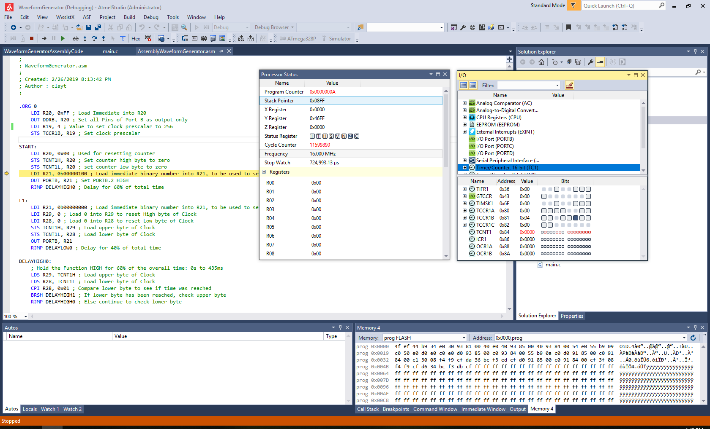

Figure - Assembly Code, Delay of 725ms shown

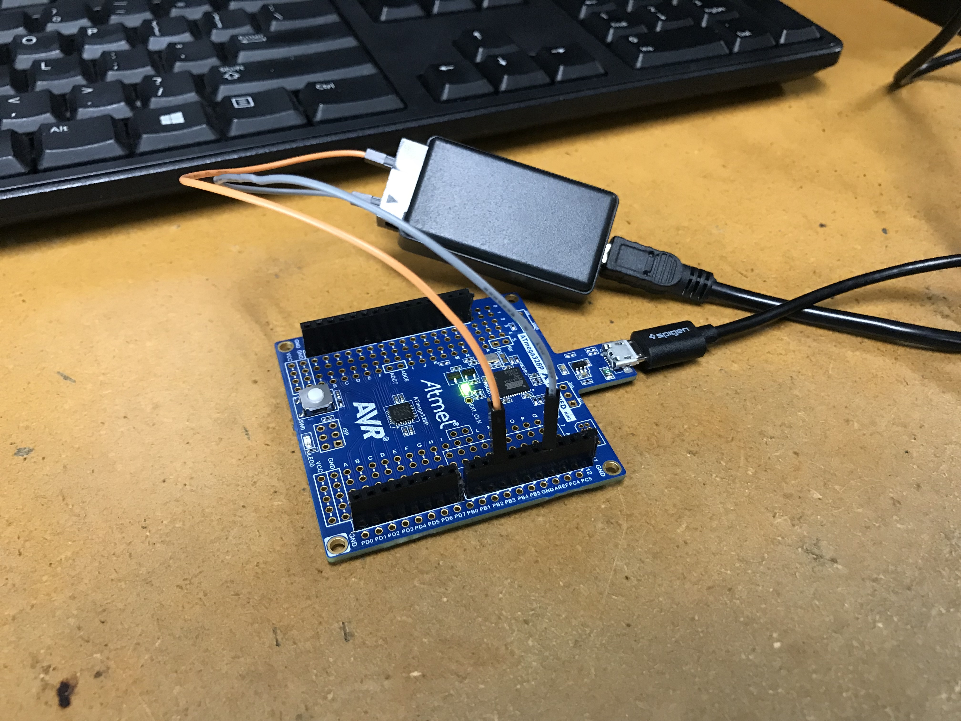

Figure - Xplained Mini board connected to Logic Analyzer

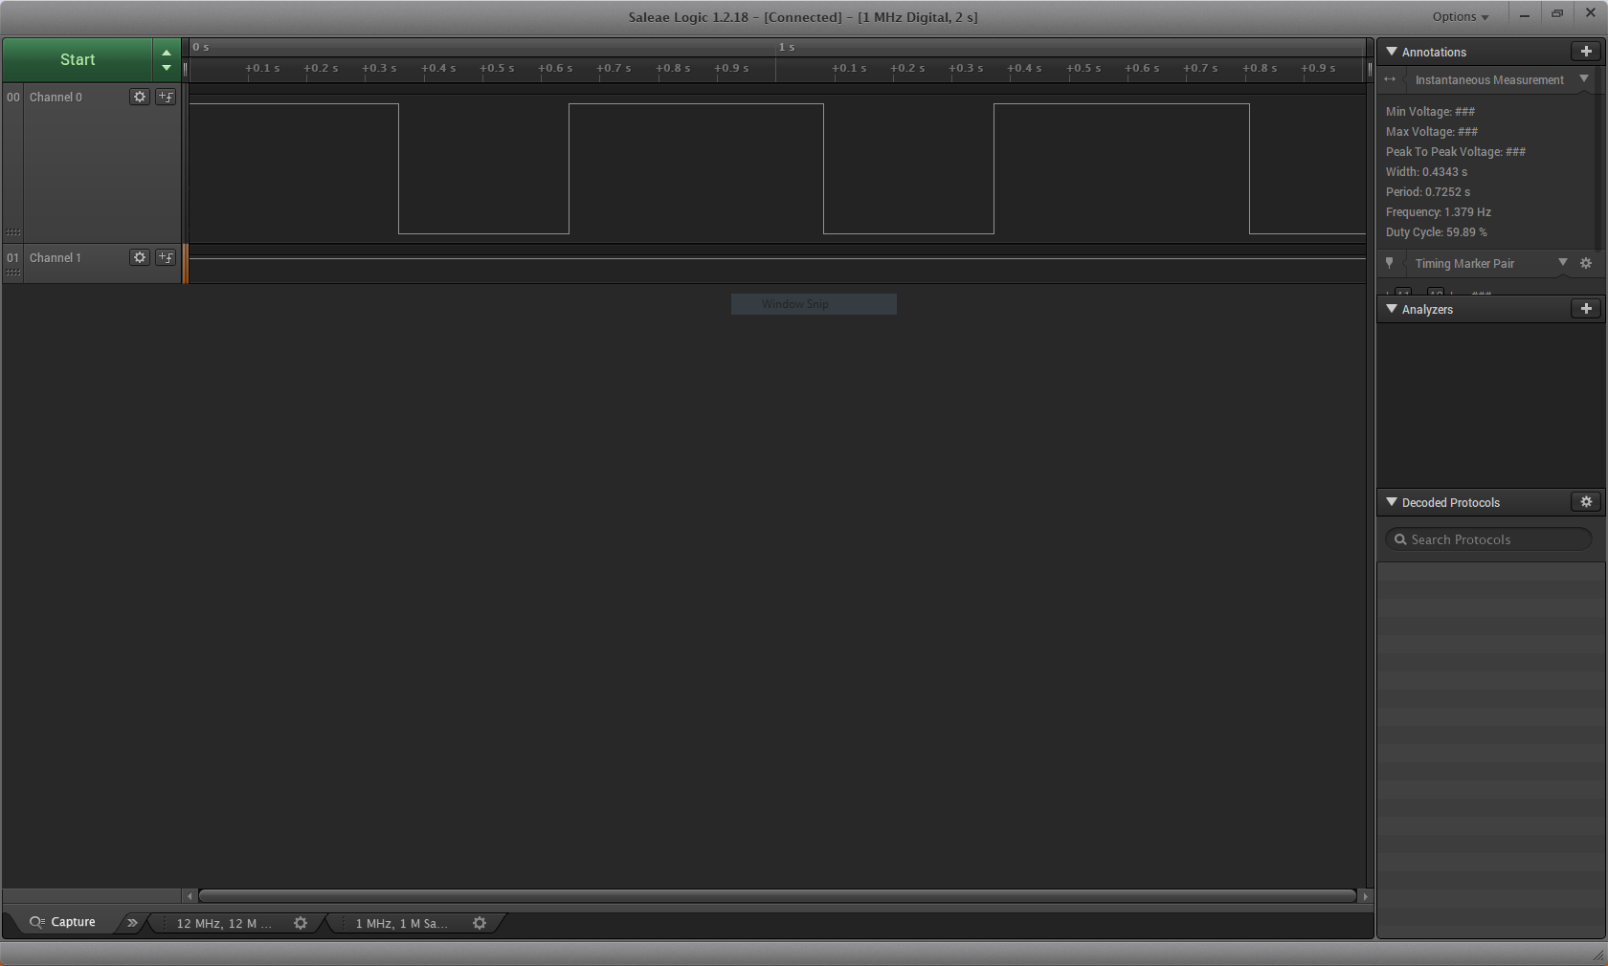

Figure - Waveform Output, 60% Duty Cycle

C Code Output:

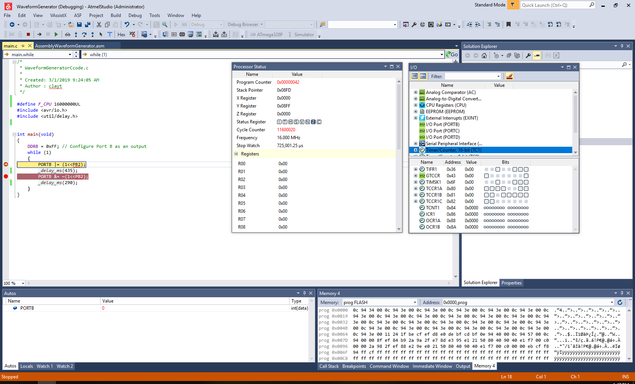

Figure - Delay at 430ms

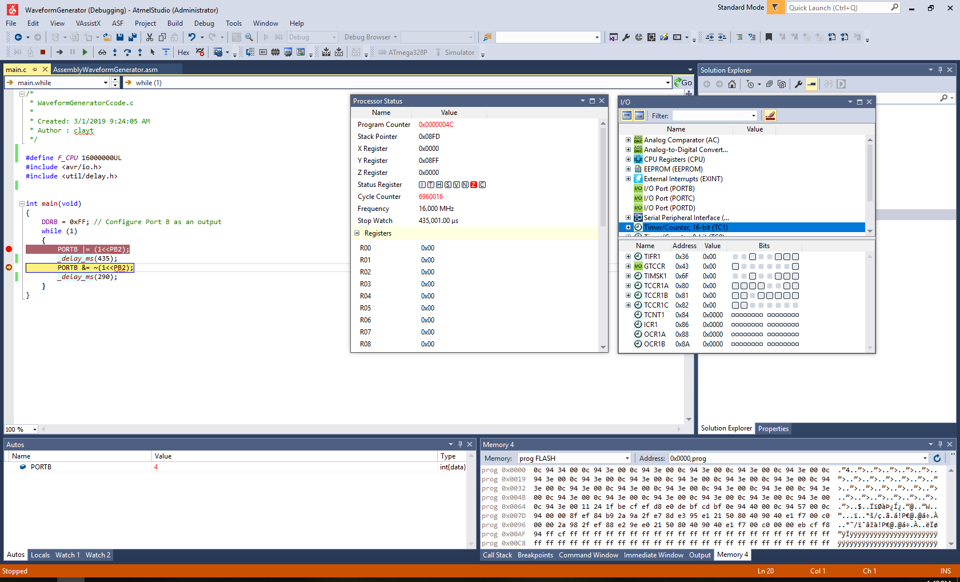

Figure - Delay at 725ms

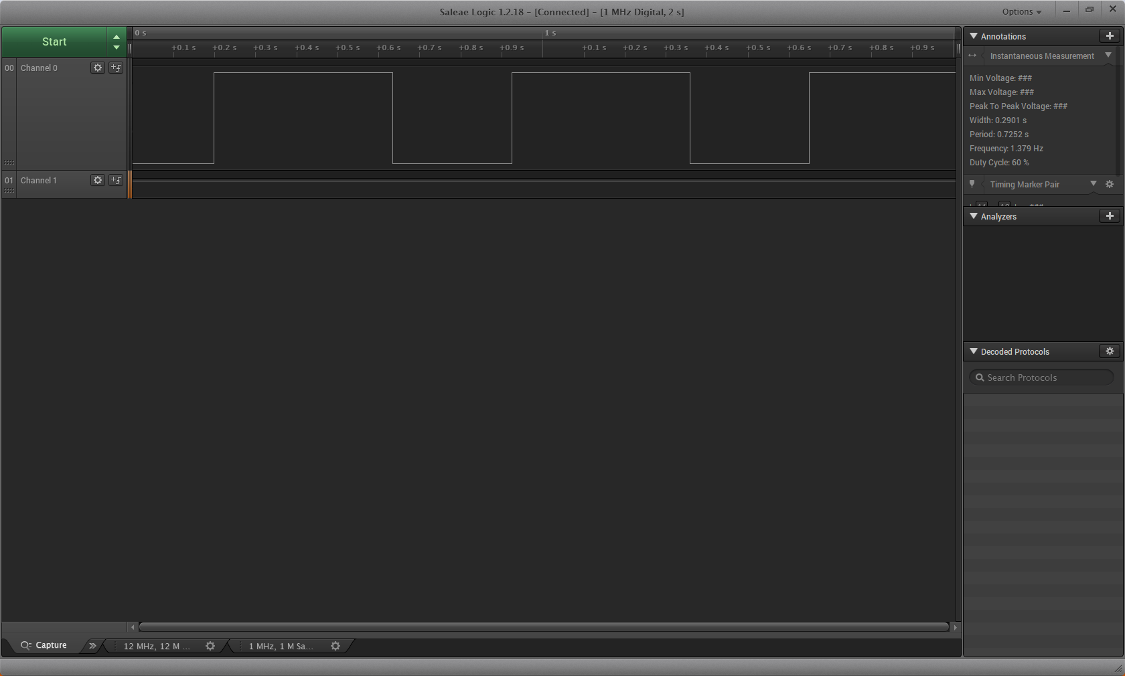

Figure - Waveform output using C Code

Task 2:

Assembly Output:

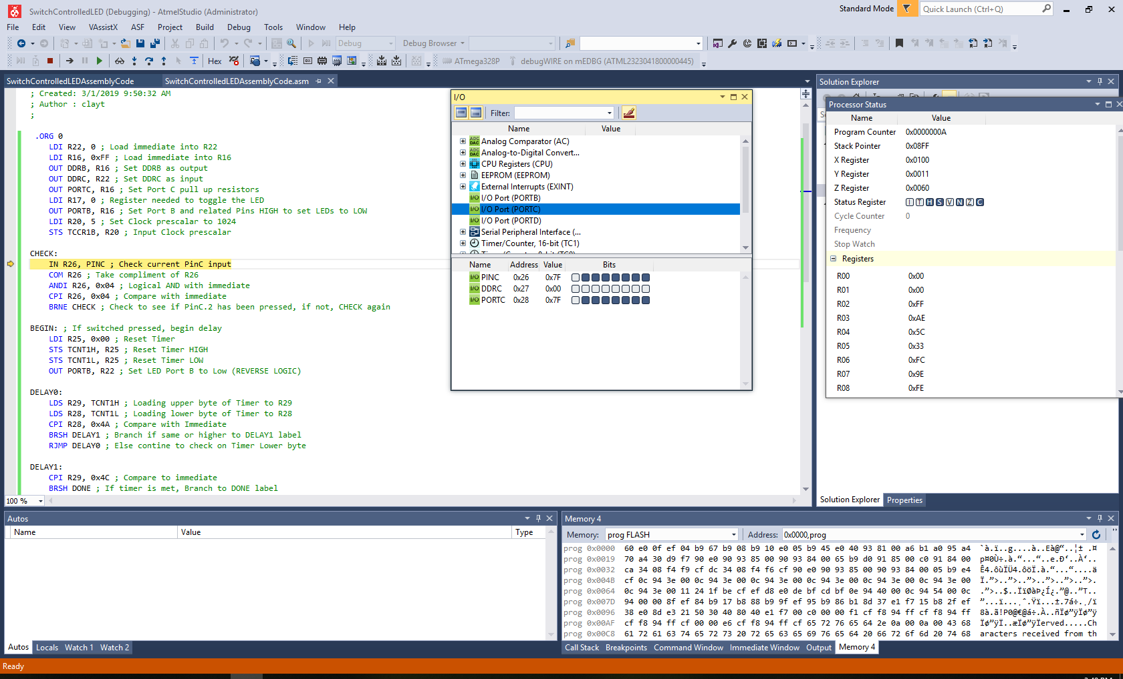

Figure - Code looking for Pin C.2 Input Change

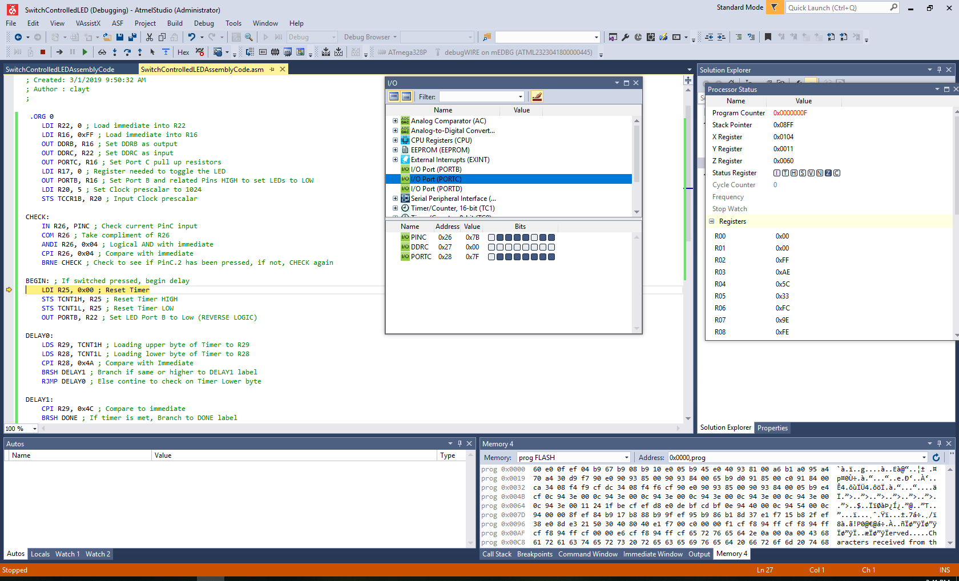

Figure - Pin C.2 Change occured and LED Change beginning to occur

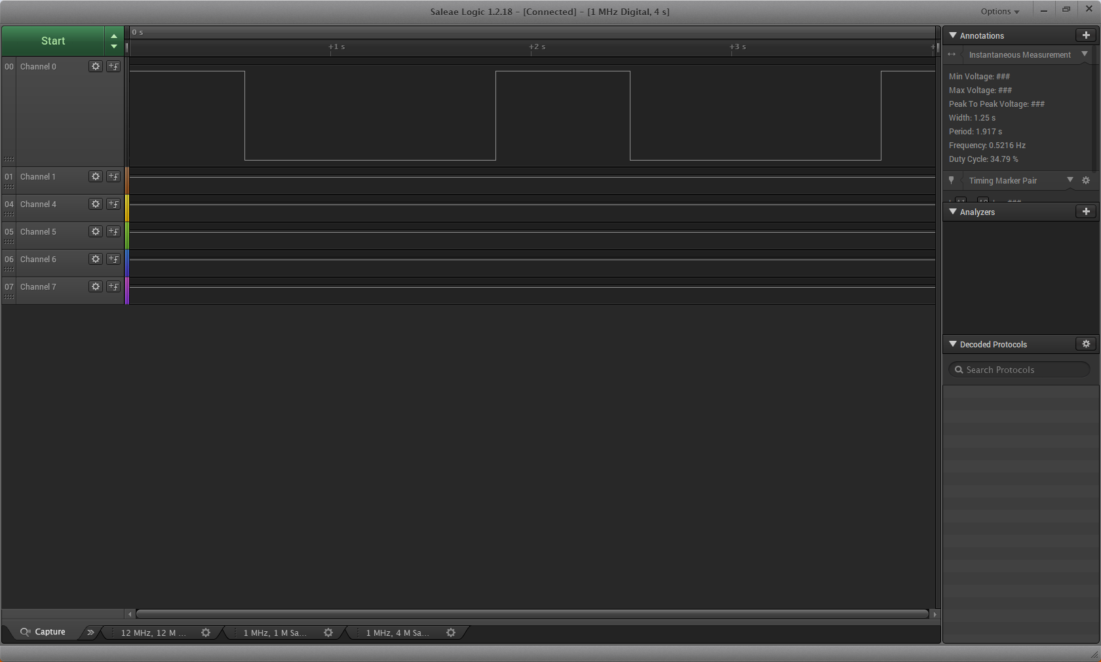

Figure - Pin Change Occurance shown in Waveform

C Code Output:

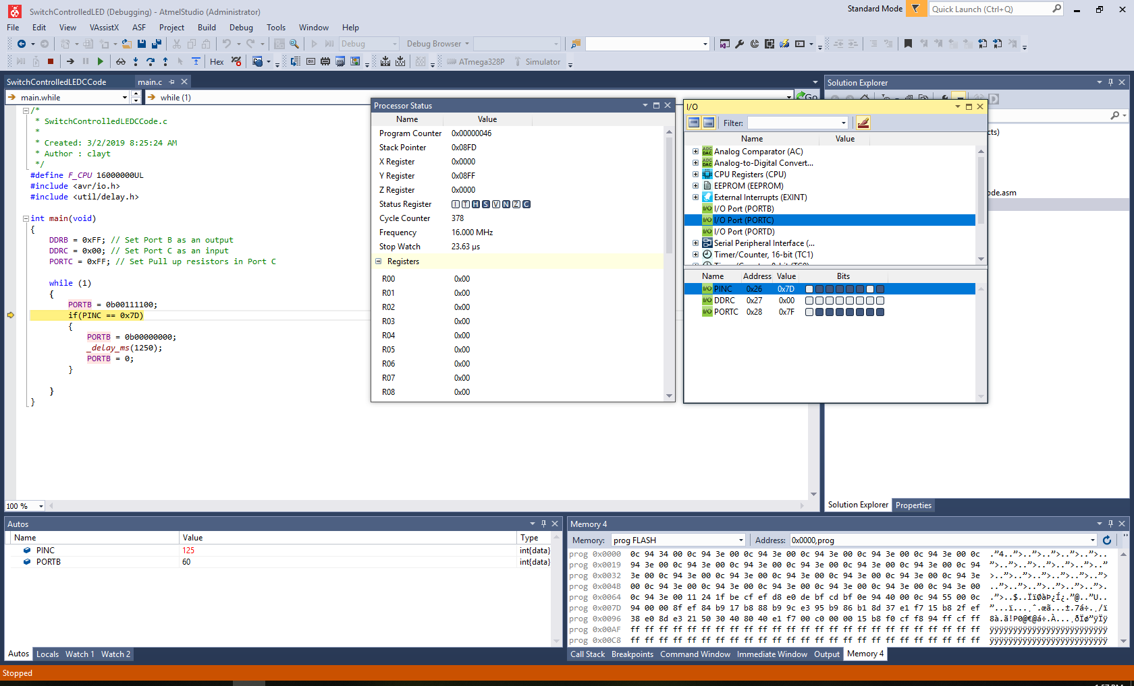

Figure - C Code waiting for input Switch

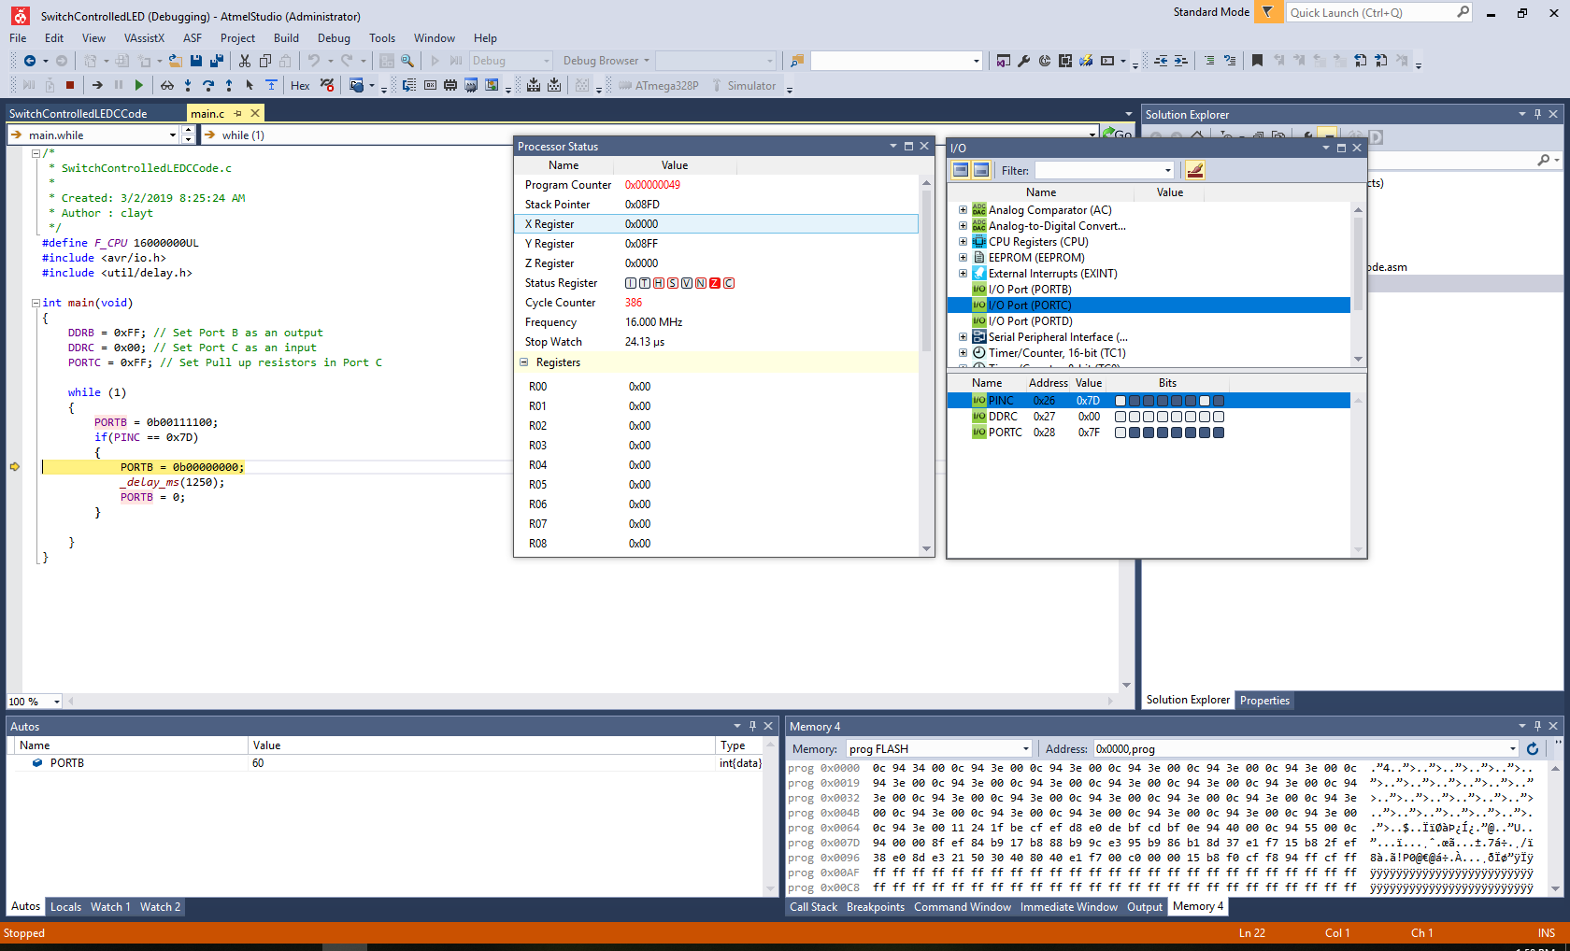

Figure - LED being set high after detecting Switch

1. **SCREENSHOT OF EACH DEMO (BOARD SETUP)**

Task 1 – Setup:

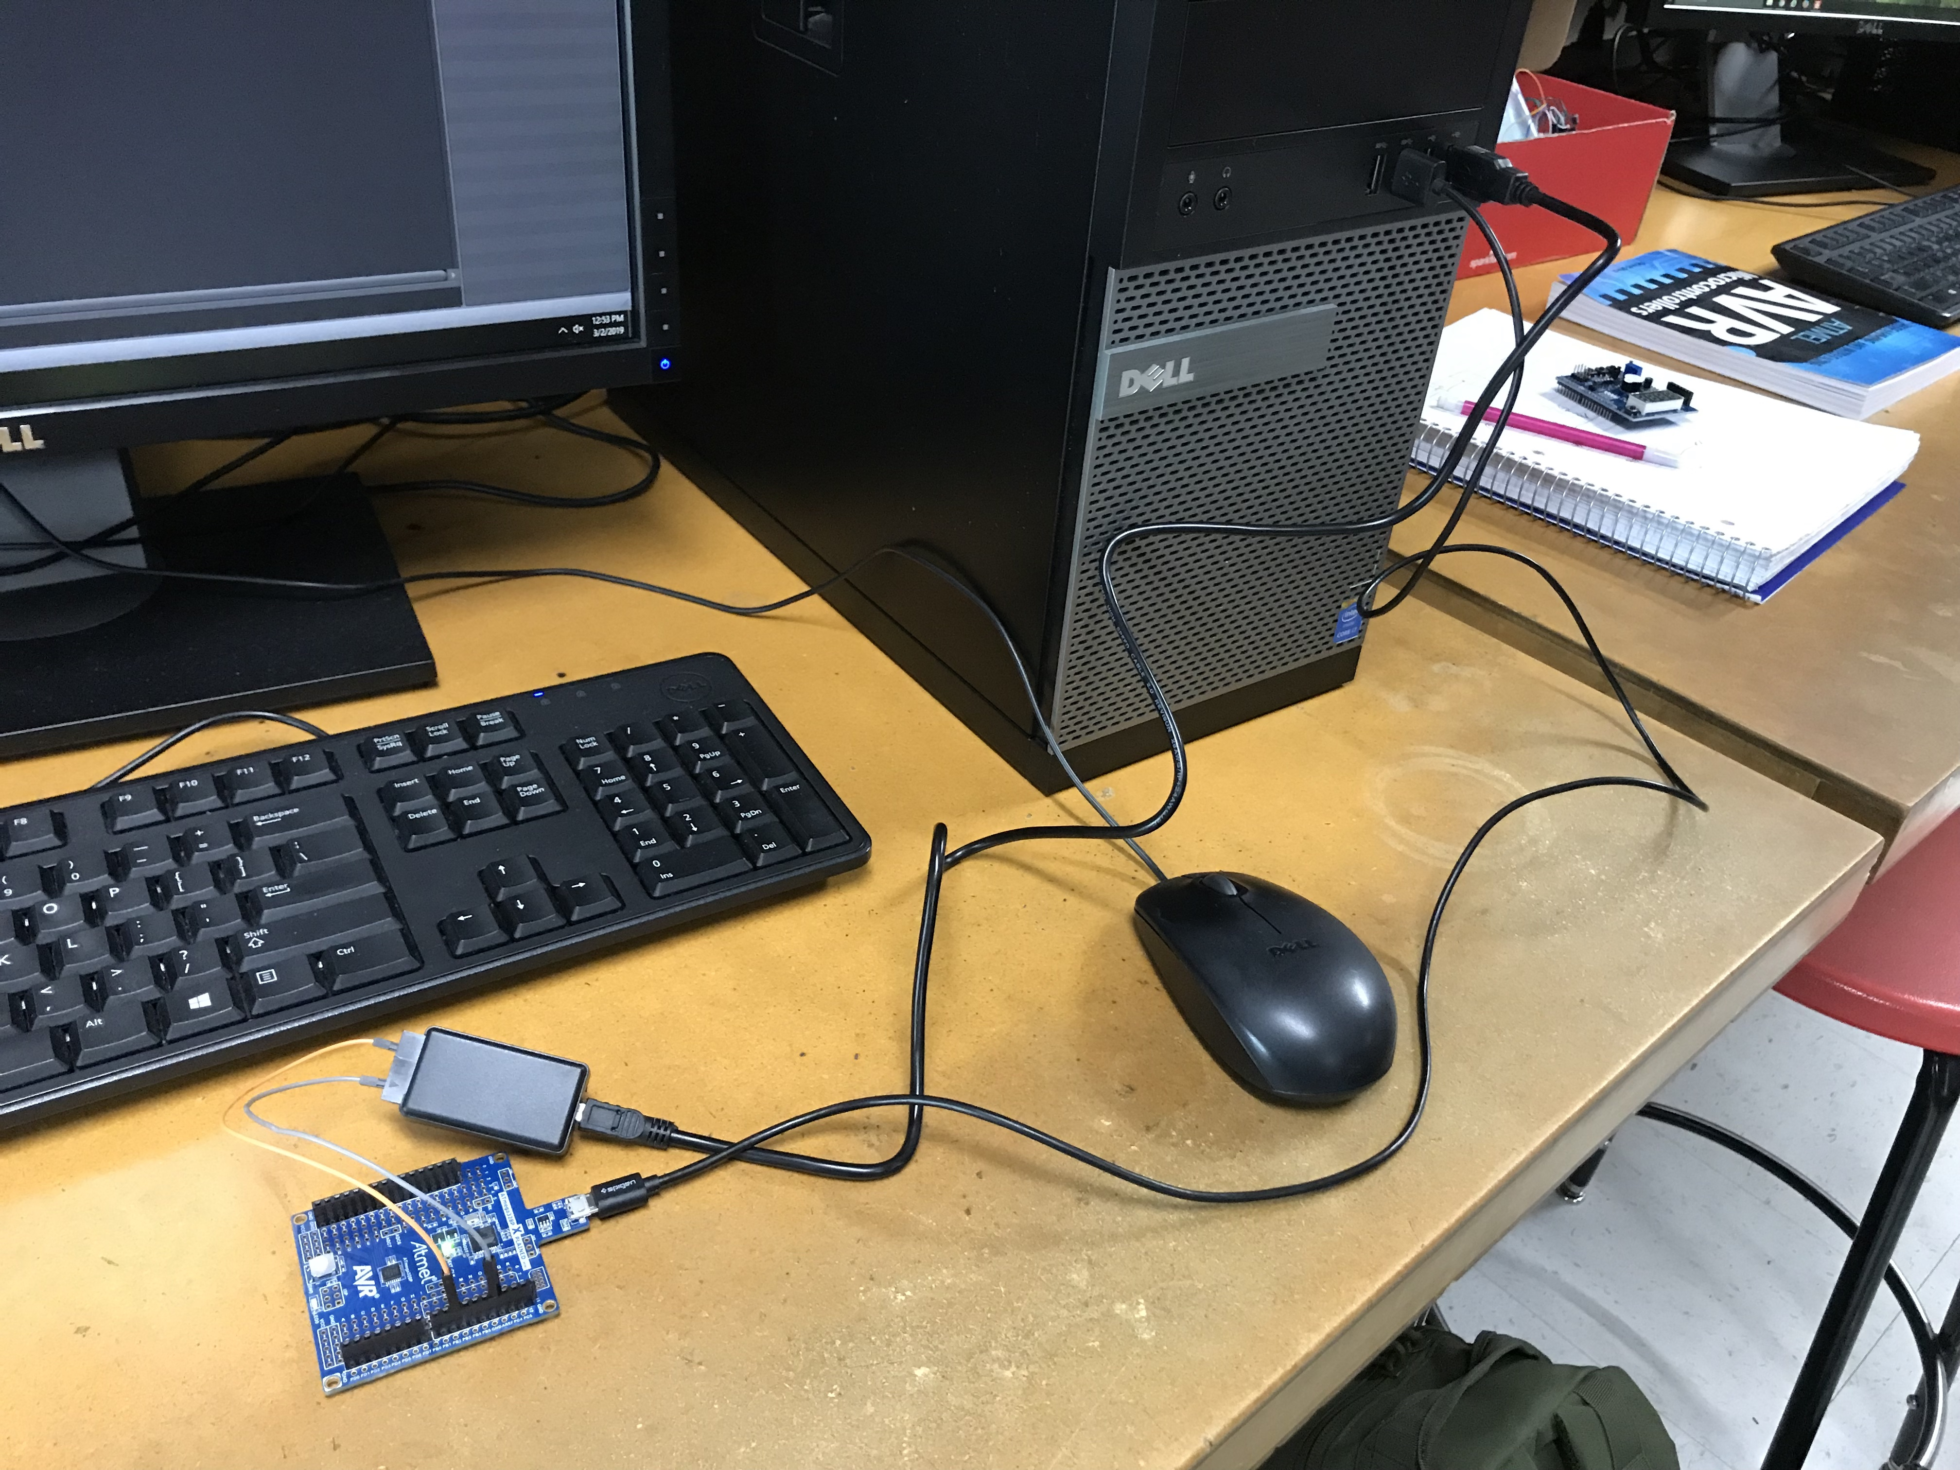

Figure - Xplained Mini connected to Logic Analyzer

Task 2 – Setup:

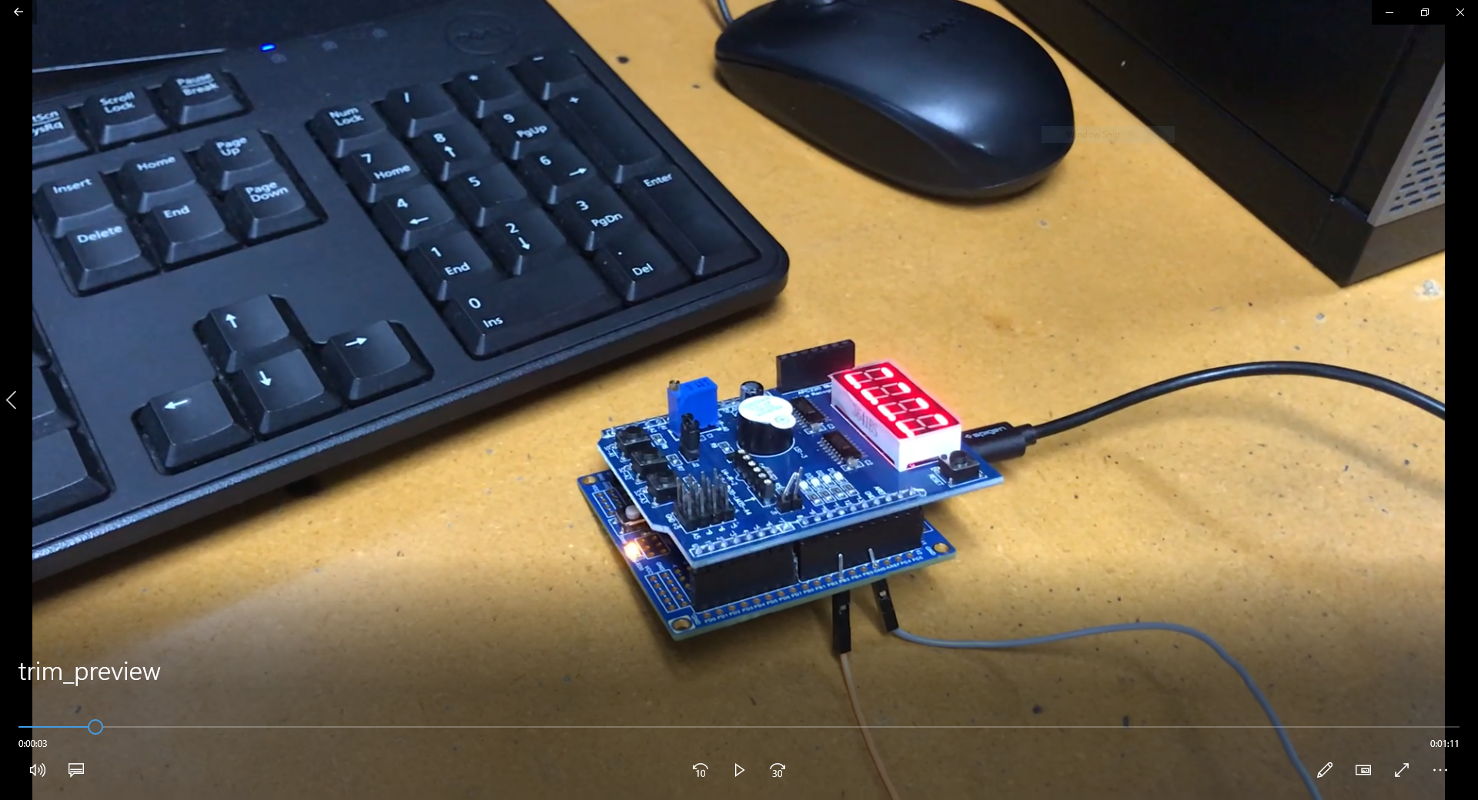

Figure - Xplained Mini Board connected to Logic Analyzer and Multi-Function Development Board

1. **VIDEO LINKS OF EACH DEMO**

Entire demo of both tasks:

<https://youtu.be/VKfgQeUb528>

1. **GITHUB LINK OF THIS DA**

<https://github.com/claytonjhigbee/CODSWORTH_MAIN/tree/master/DA/DA2A>

**Student Academic Misconduct Policy**

<http://studentconduct.unlv.edu/misconduct/policy.html>

“This assignment submission is my own, original work”.

Clayton Higbee